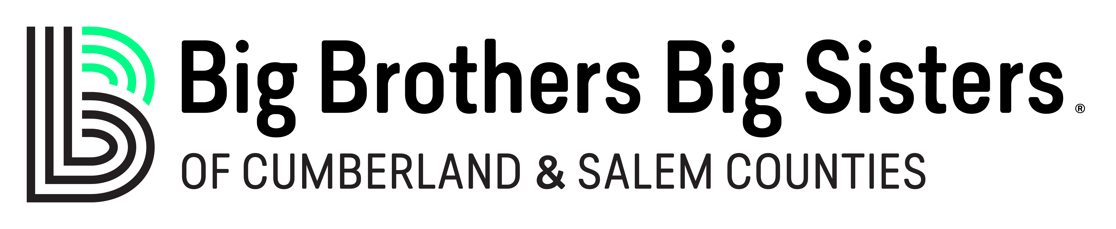*2023

1. I would like to become a BBBS Society Member for 5 Years:
Dream Maker $10,000.00 per year Magic Maker $5,000.00 per year
Memory Maker $2,500.00 per year Match Maker $1,500.00 per year

2. I am currently a Society Member or multi-year donor:
I am enclosing my current pledge payment. Cash Check Credit Card
I will pay my next pledge payment later.
Please increase the annual amount of my multi-year pledge to $ per year.

3. I would like to become a multi-year donor:
I pledge $ for year(s).

4. I would like to give a One-Time Gift of:
$

5. I would like to give in other ways:
Contact me about: Volunteering – Mentoring – Office Helper – Special Event Planning
Contact me about a bequest giving.
Contact me about giving with appreciated stock or property.

6. Please Print Clearly: Payment: Bill Me: Annually Semi-Annual Quarterly
My check is enclosed, payable to BBBS. Check # Cash $
Charge my VISA / MC / AMEX / DISC $ Annually Quarterly Monthly
# Exp: Signature:
Name: Date:
Organization:
Work/Home Address:
City, State, Zip: Work #:
Home / Cell #: Email Address: I would like my pledge to be anonymous. Please contact me, I have other thoughts to share

